* Meet the New Believers

IMAGE: Collage of the ULCH Glee groups

* Full of hope, promise and perseverance.

IMAGE: Inspiring. Happy, on top of the mountain, climbing tall stairs

* With dreams of bringing the best performance ever!

IMAGE: 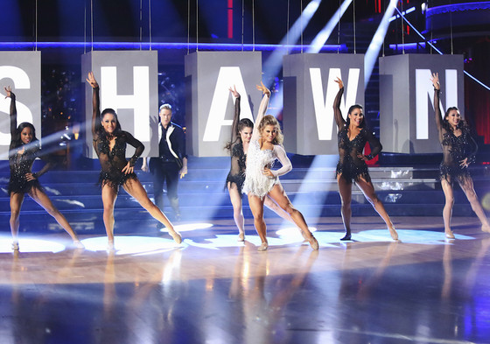

* They get a task. They act on it…and they act on it with force.



* There’s no stopping these guys.

IMAGE: Running

* Despite the hurdles
* No holidays since last year

IMAGE: Missing the family, Christmas icon with x mark

* Confusion with the choice of songs

IMAGE: Confused person, angry, photo of microphones

* A load of last minute changes

IMAGE: Song notes/key note, song titles (from Glee)

* Questions on technical details because of its impact to a spectacular performance

IMAGE: wiring, speakers, fireworks, confetti

* Cost of costumes and props

IMAGE: Peso signs, costumes, props

* Questions on guidelines and mechanics, to make sure everything are just right!

IMAGE: papers, words on screen: guidelines, mechanics, 50 points (text --- this is the high score)

* Hired professional choreographers / consultants

IMAGE: dance instructor, group following instructor in front

* Late rehearsals up to wee hours of the night

IMAGE: sleepy, tired, pawisan, 12MN

* Health sacrifices because of late nights

IMAGE: super tired, pale, hilo face

* Physical pain due to rehearsals

IMAGE: bandages, band aid, first aid

* They still took their time intensely rehearsing

IMAGE: people dancing sweaty

* In order to present
* The most spectacular of performances
* So never stop believing. Because dreams do come true.
* If you’re like these guys

IMAGE: COLLAGE OF ULCH PHOTOS (bawas from the first collage)

* Then you’ve got what it takes!
* Presenting the dreamers…

IMAGE: Use the old slides --- intro of group performers. Glee Groups (same photos)

* + Gutsy Gold
  + Blue Bold
  + Gung-ho Green
  + Purposeful Purple
  + Resilient Red
* Expect something big. Expect the Unexpected.

IMAGE: Gleevolution